EXPERIMENT NO : 1

NAME : SAHIL TRIPATHI

AIM : Write a Verilog code for the implementation of all gates. –

OR GATE

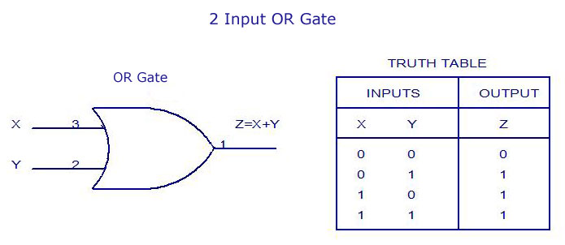

VERILOG CODE -

module or_gate(

input a,

input b,

output c

);

wire c;

or(c,a,b);

endmodule

IMAGE OF CODE -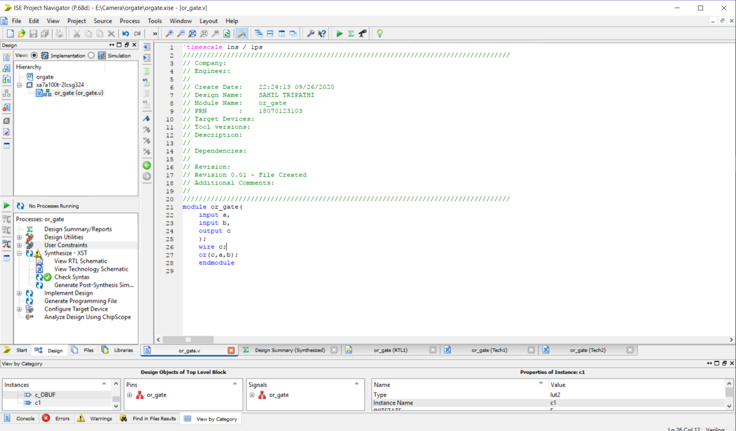

RTL IMAGE OF OR GATE-

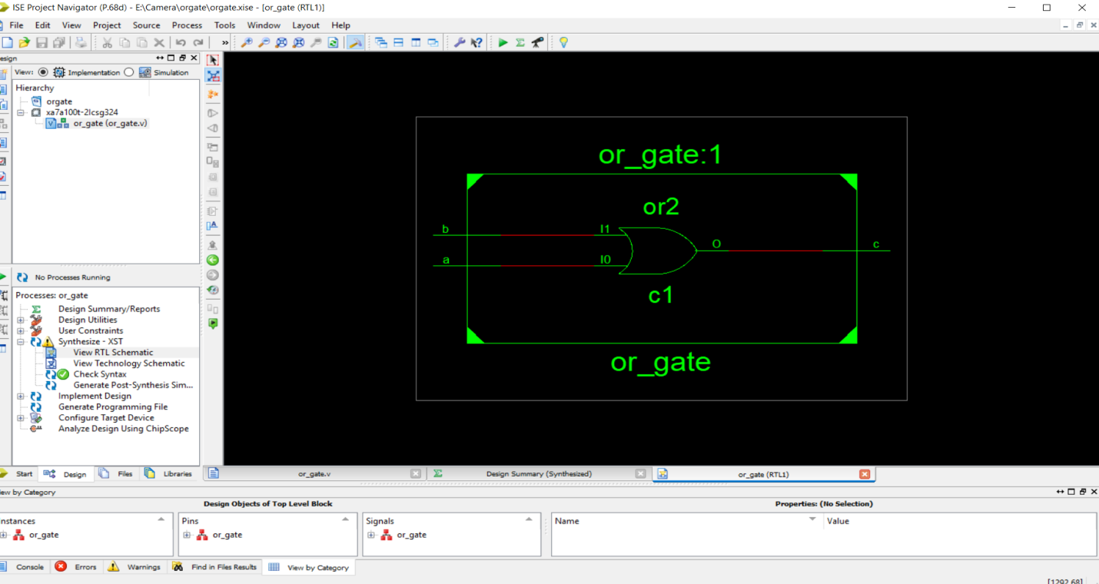

TECHNOLOGY SCHEMATICS

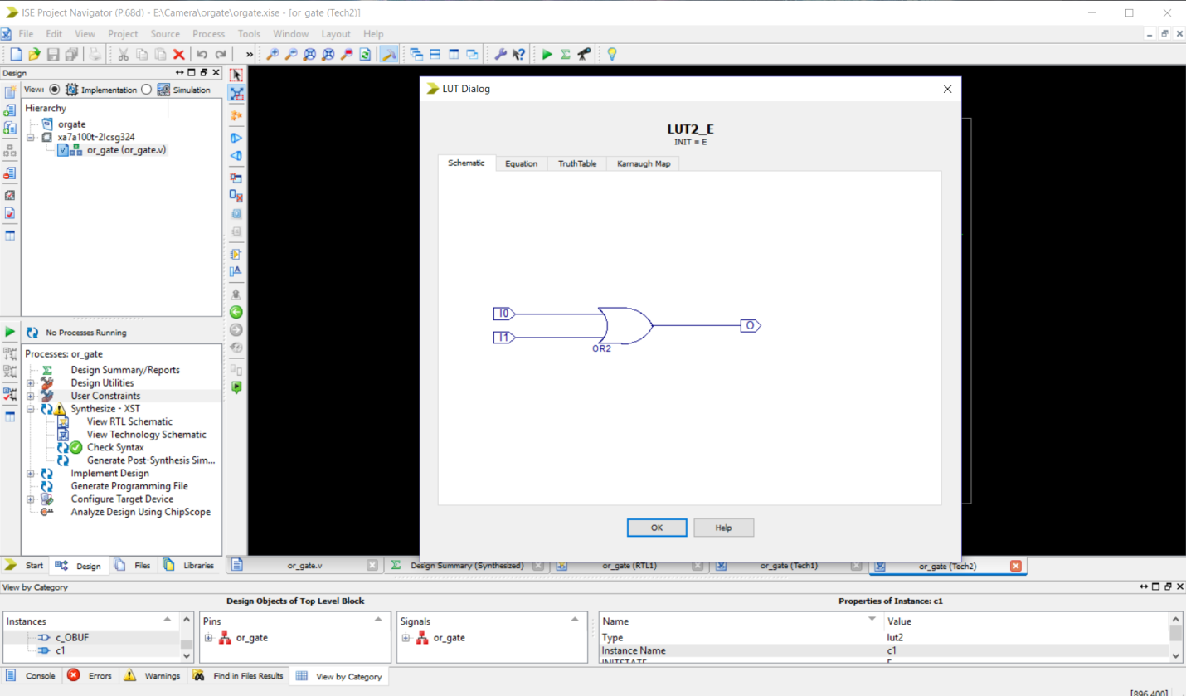

SIMULATION OF OR GATE

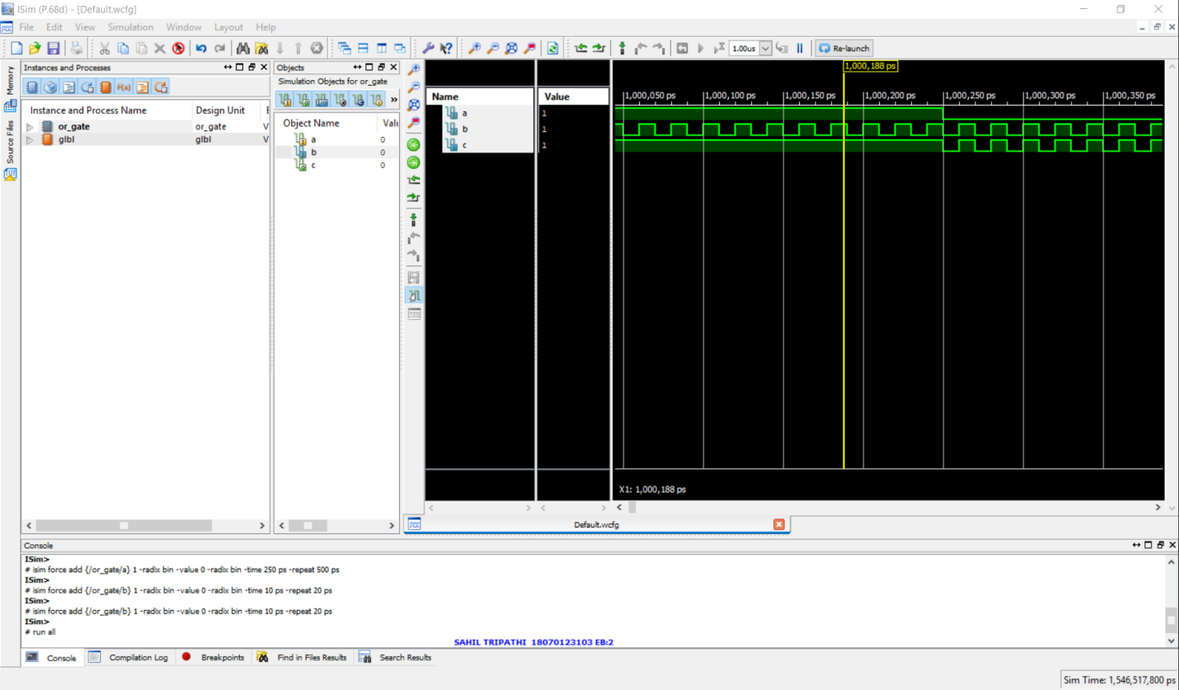

## AND GATE

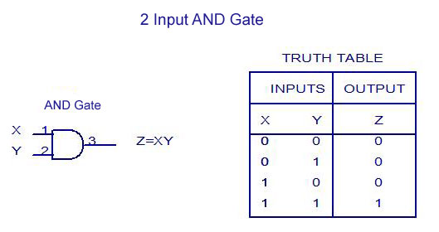

CODE FOR AND

module basicgate(

input a,

input b,

output c

);

wire c;

and(c,a,b);

endmodule

IMAGE OF CODE –

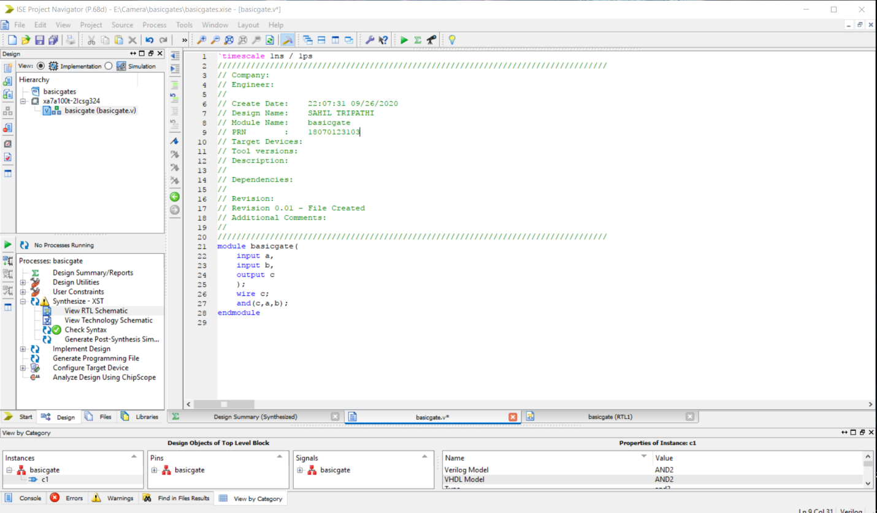

RTL IMAGE OF AND

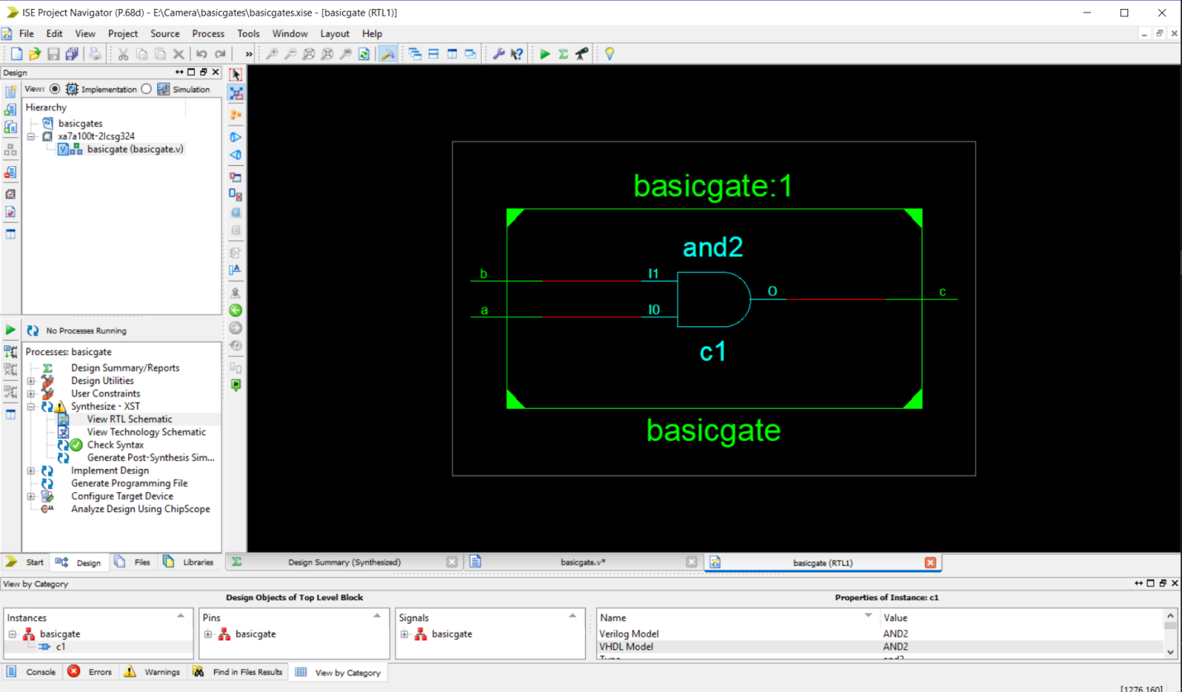

TECHNOLOGY SCHEMATICS

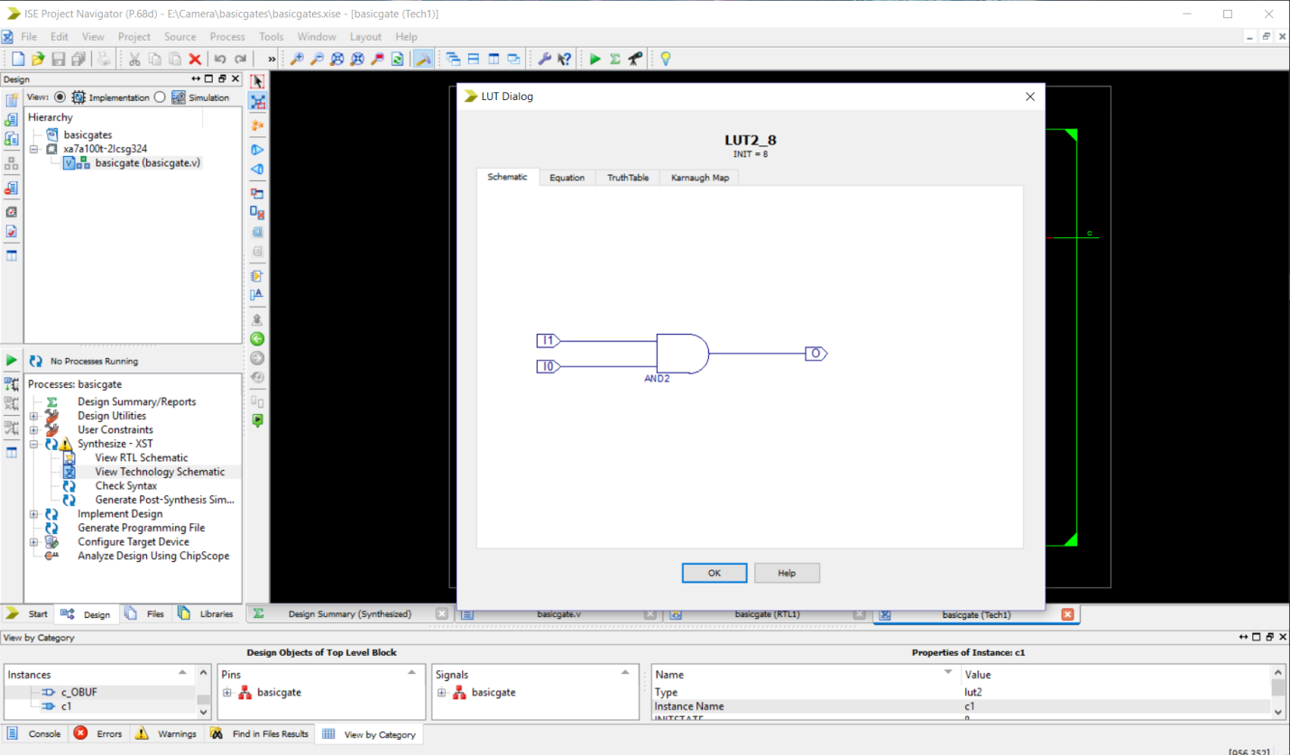

SIMULATION OF AND

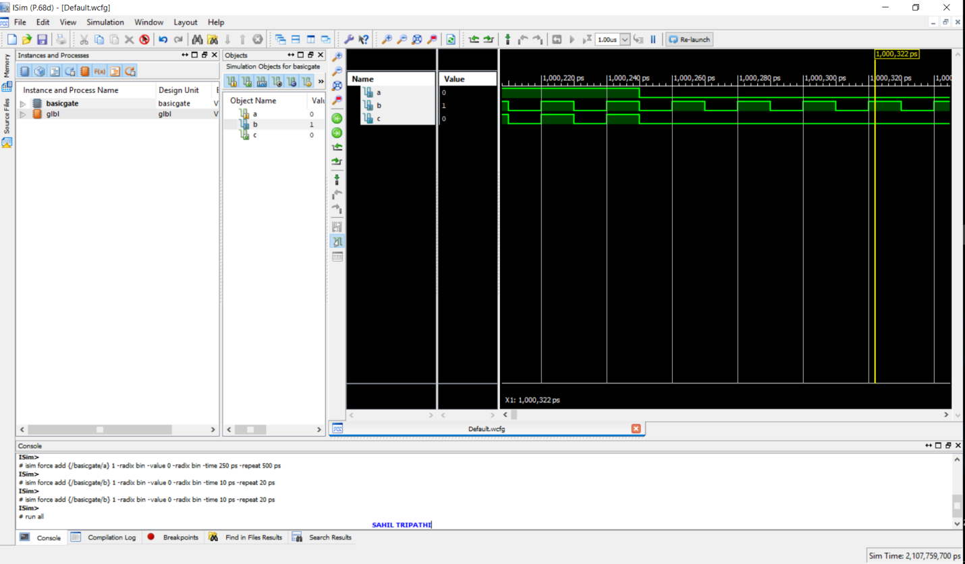

## NOT GATE

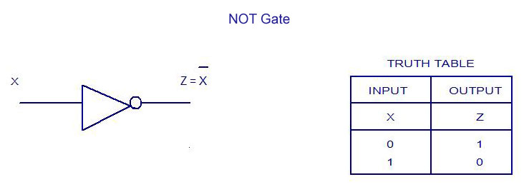

CODE FOR NOT GATE

module NOT_GATE(

input a,

output b

);

wire b;

not(b,a);

endmodule

IMAGE FOR CODE-

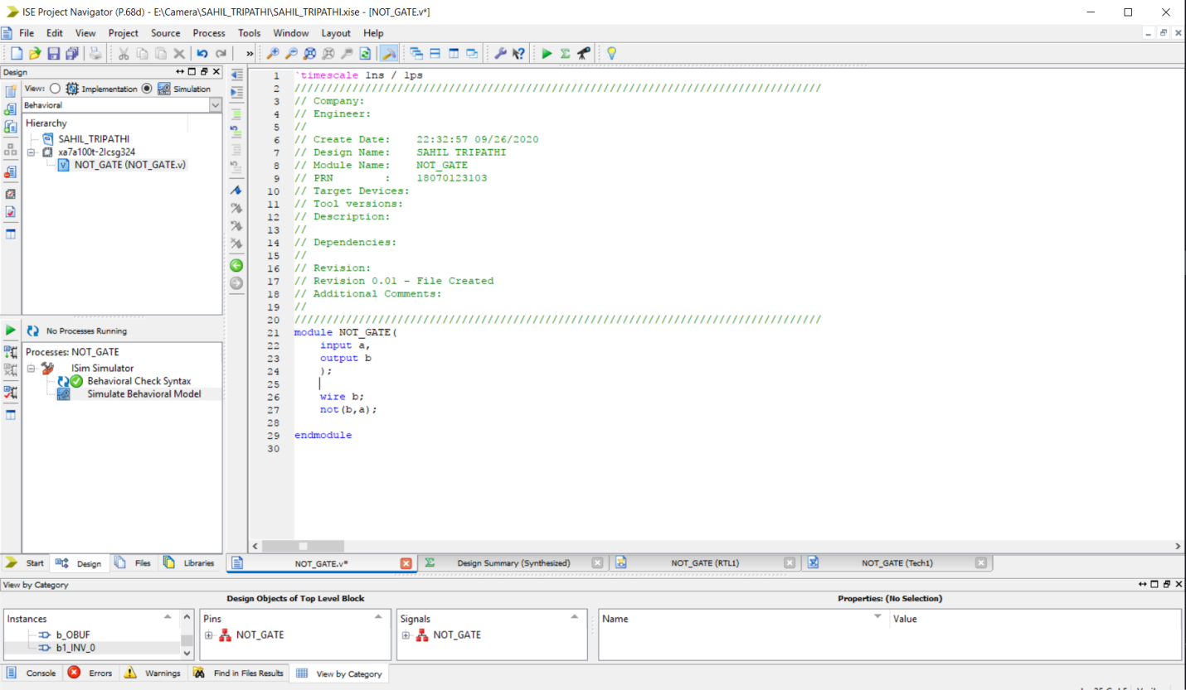

RTL OF NOT GATE

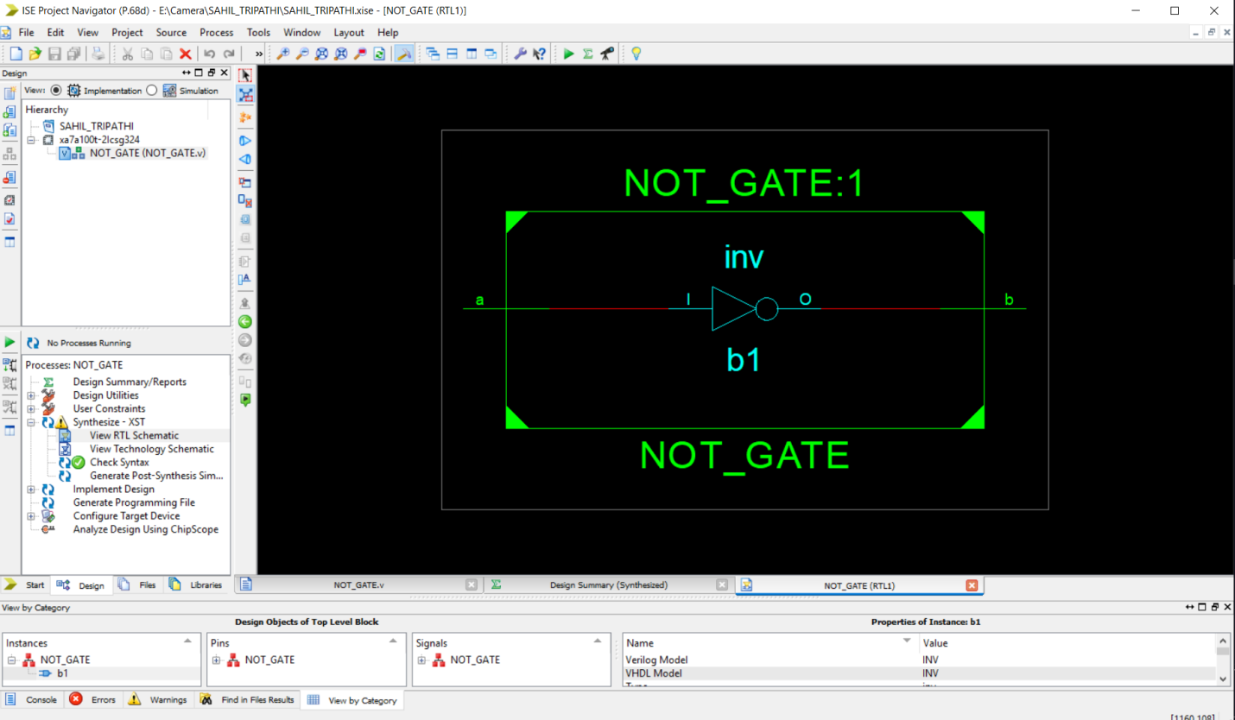

TECHNOLOGY SCHEMATICS

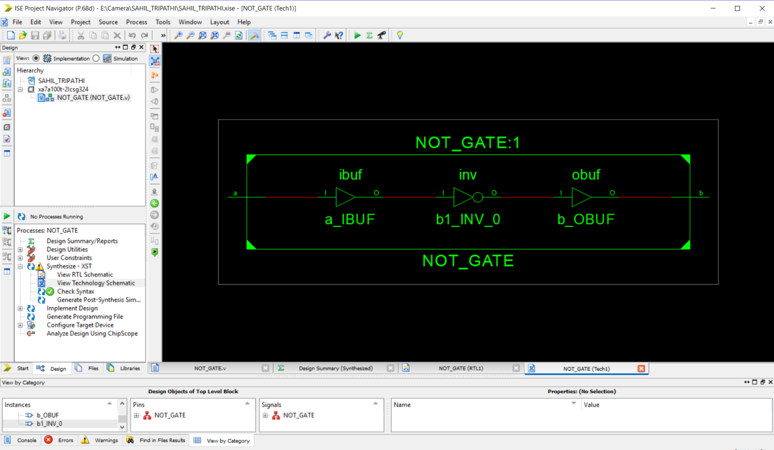

SIMULATION OF NOT

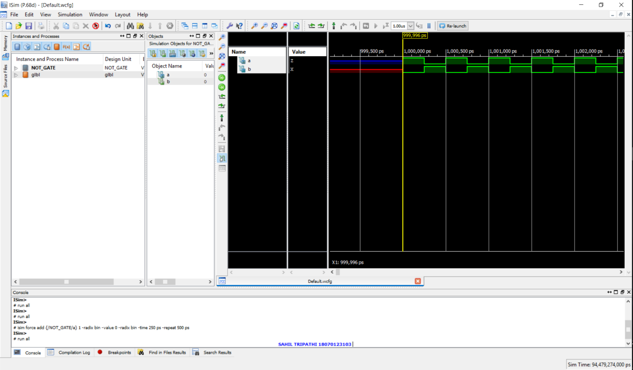

SO HENCE WE HAVE LEARNED HOW TO IMPLEMENT LOGIC GATES & SIMULATE IN XILIN SOFTWARE .